# Important Instructions

These instructions are meant for students to make the best use of this course.

1. ***Issue with blurry videos*** – All videos are recorded in either 720p or 1080p. All videos are of high quality. There can be cases wherein users complain of blurry videos as shown below

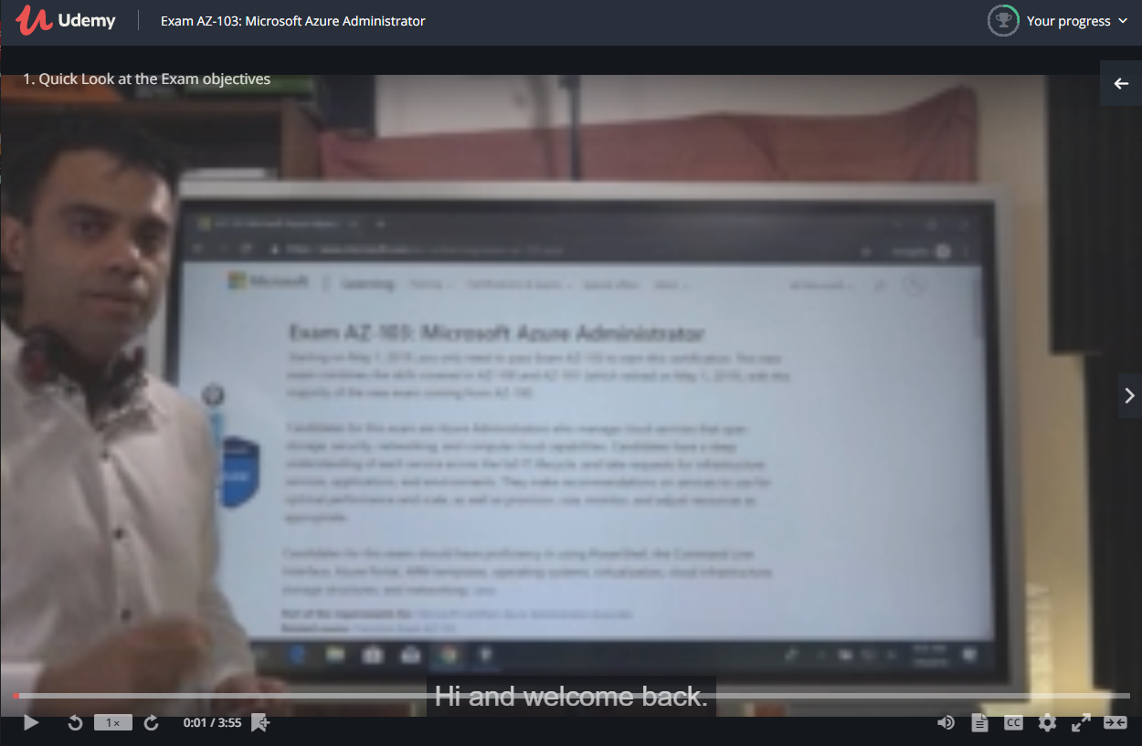

This is because of the resolution of the video player. Please follow the below steps to rectify this issue

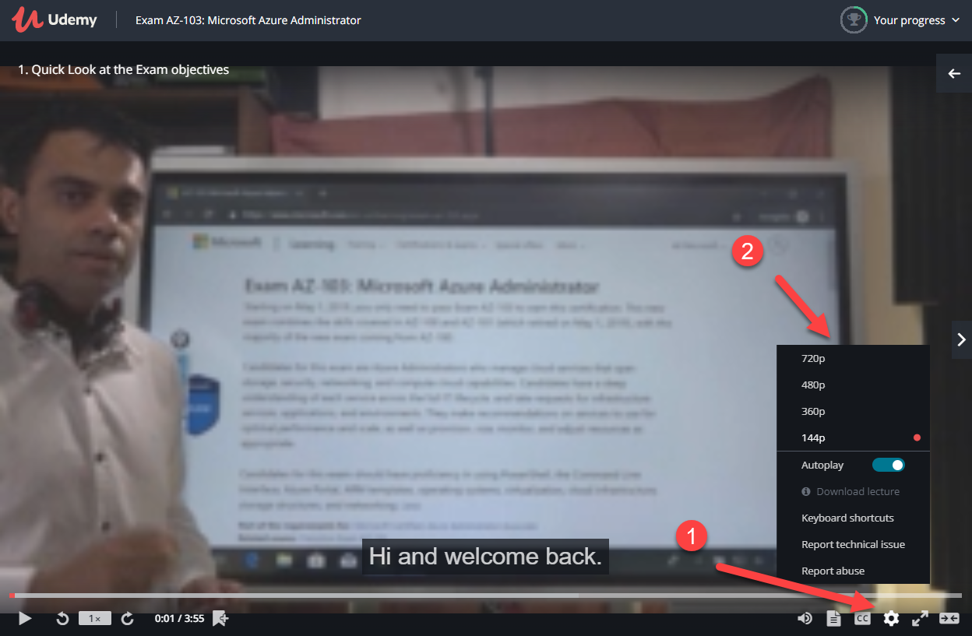

1. Go to your settings
2. Change the resolution to 720p

This will improve the quality of the video

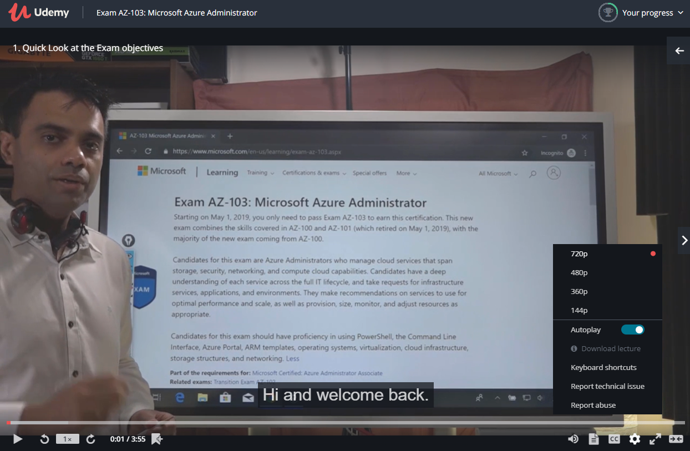

1. ***Lecture for download*** – Those lectures which are huge in size are made available for download for viewing later on

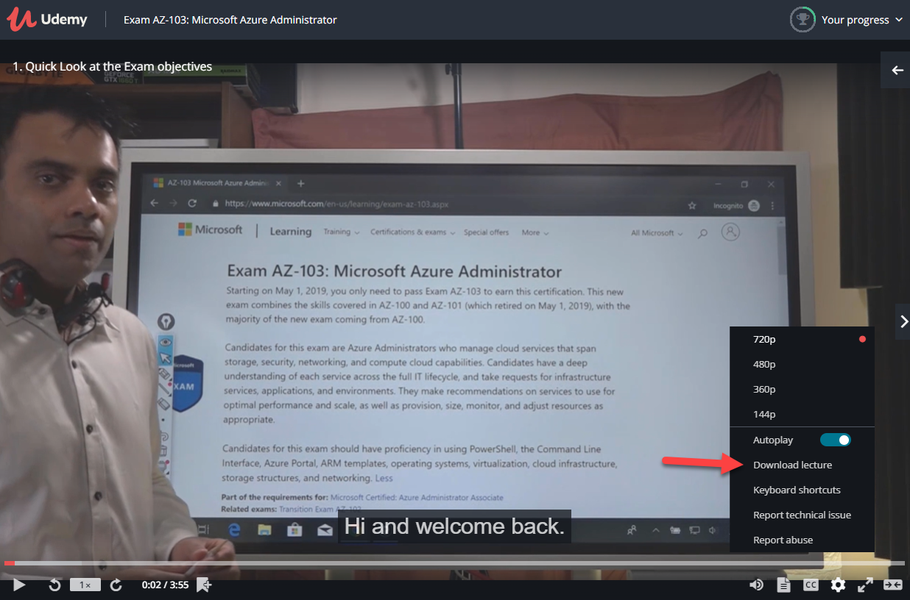

Go to settings and choose “Download lecture”

**Note: - Not all lectures are available for download. This is because of videos being distributed without the author’s consent.**